**Daily Scrum or Standup Meeting**

Team name: Group 8_________________________

Scrum Master: Cole_______________________

Date: 3-19-2021_______________________________

|  |  |  |  |
| --- | --- | --- | --- |
| **Team Member** | **What did you do since the last scrum?** | **What do you plan to do before the next scrum?** | **What obstacles do you have?** |
| Jeremy | Made a lot of progress on the backend | Work on figuring out different authentication levels and signup | None |
| Cole | Finished getting Austin’s code to run | Unclear | Waiting on further guidance from Austin |
| Austin | Worked on breadcrumbs in customer views | A lot | Time |
| Logan | N/A | N/A | Time |
|  |  |  |  |

# Burndown

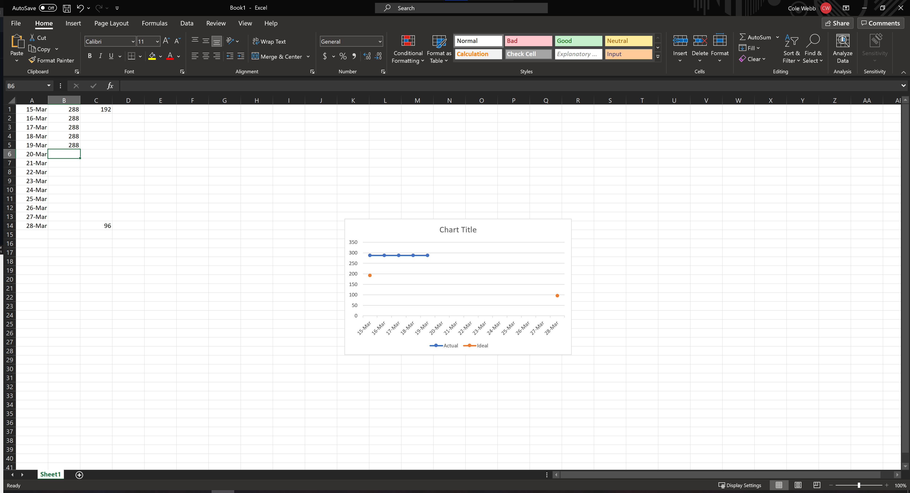

# Screenshot of you project board

